Earth Relay Fault

Author：胡维
Reviewer：Eason

FAQ\Hybrid INV
Issue introduction:
The inverter screen displays:Earth relay fault.
Confirmation of basic information：
[Photo]SN numbers of the inverter.
Guidance for installer
Step1: Upgrade the firmware version to the latest.
Step2:This usually occurs during the switch between grid-connected and off-grid modes. Try toggling a few times to see if the error is triggered again.
Information check list :
If you have completed the above <Guidance for installer>, and the problem is still not solved, please collect the following troubleshooting information and send them to the R&D.
- [Photo]SN numbers of the inverter.
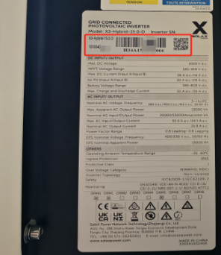
2.[Video]On grid and off grid switching.

